ULTRASONIC TESTING REPORT
Company/Client |  | NCOC N. V. |  | Project |  | ESKENE WEST KARABATAN |  | Location |  | OSF
Line No/Tag No: |  | M2-6902-VK-101B |  | Material |  | Carbon steel |  | Día × Nominal Thickness |  | No information
Procedure No |  | QP-11-UTT-Q01 Rev 03  GOST 28702-90 |  | Calibration Block |  | CS Step wedge |  | Probe  S/N |  | D790  1196661
 |  |  |  | Calibration block Range |  | 2.5-12.5 mm |  | Angle |  | 0º
Manufacturing Code |  | 97/23/EC |  | Calibration Temp |  | +22º |  | Frequency |  | 5 MHz
 |  |  |  | Object Temp |  | +23º |  | Size |  | 11 mm
Acceptance Standard: |  | Acc. To the client specif. |  | Correction factors |  | n/a |  | Crystal |  | Dual
Surface condition |  | Coated |  | Couplant |  | UT Gel |  | Accuracy |  | ± 0,1 mm
S. No | Equipment/  Material Name |  | Manufacturer |  | Serial No |  | Calibration certificate No |  | Calibration Expiry date
 | A-scan UT DL-38 |  | OLYMPUS |  | 171421601 |  | 2113237 |  | 02.04.2020
 | Step wedge calibration block |  | OLYMPUS |  | 026519 |  | - |  | -
Job description:

- UT measurements were conducted on the M2-6902-VK-101B
- UT thickness measurement was done by Echo to Echo method.

Notes:
N/A – not applicable.
FSH – Full Screen Height

DETAILS AND RESULTS
M2-6902-VK-101B

27L/9412
27P/9430

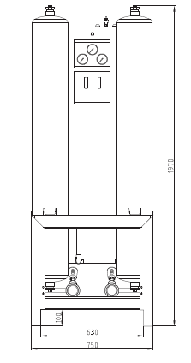
Section-2
Section-1
Section-3
Section-3
Section-2
Section-1
Section-4
Bottom head
Section-4
Top head
Top head
Bottom head

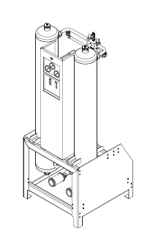
S/NO | description | Dia | Item | Nominal thickness, mm | East  mm | West  mm | South  mm | North  mm
 | M2-6902-VK-101B  (27L/9412) | No information | Top head-1 | No information | 6.15 | 6.17 | 6.14 | 6.14
 | M2-6902-VK-101B  (27L/9412) | No information | Section-1 | No information | 6.10 | 6.14 | 6.12 | 6.12
 | M2-6902-VK-101B  (27L/9412) | No information | Section-2 | No information | 6.08 | 6.08 | 6.09 | 6.10
 | M2-6902-VK-101B  (27L/9412) | No information | Section-3 | No information | 6.06 | 6.14 | 6.05 | 6.09
 | M2-6902-VK-101B  (27L/9412) | No information | Section-4 | No information | 6.08 | N/A | 6.12 | 6.10
 | M2-6902-VK-101B  (27L/9412) | No information | Bottom head-2 | No information | 6.09 | 6.09 | 6.12 | 6.11
 | M2-6902-VK-101B  (27P/9430) | No information | Top head-1 | No information | 6.14 | 6.13 | 6.14 | 6.11
 | M2-6902-VK-101B  (27P/9430) | No information | Section-1 | No information | 6.05 | 6.07 | 6.08 | 6.10
 | M2-6902-VK-101B  (27P/9430) | No information | Section-2 | No information | 6.09 | 6.08 | 6.10 | 6.11
 | M2-6902-VK-101B  (27P/9430) | No information | Section-3 | No information | 6.08 | 6.07 | 6.15 | 6.09
 | M2-6902-VK-101B  (27P/9430) | No information | Section-4 | No information | N/A | 6.07 | 6.07 | 6.11
 | M2-6902-VK-101B  (27P/9430) | No information | Bottom head | No information | 6.16 | 6.17 | 6.18 | 6.14

Examined by  UT L II cert. No 048  expiry date: 01.03.2020 | Name: Kosmukhambetov Rustembek | Signature: ............................. | Date: 03-Dec-2019
Approved by UT Level II  cer. No 1A 253/15  exp date: 31.05.2020 | Name: Shakunou Andrei | Signature: ............................ | Date: 03-Dec-2019
Client Representative: | Name: ……………………… | Signature: ............................ | Date: ……………

